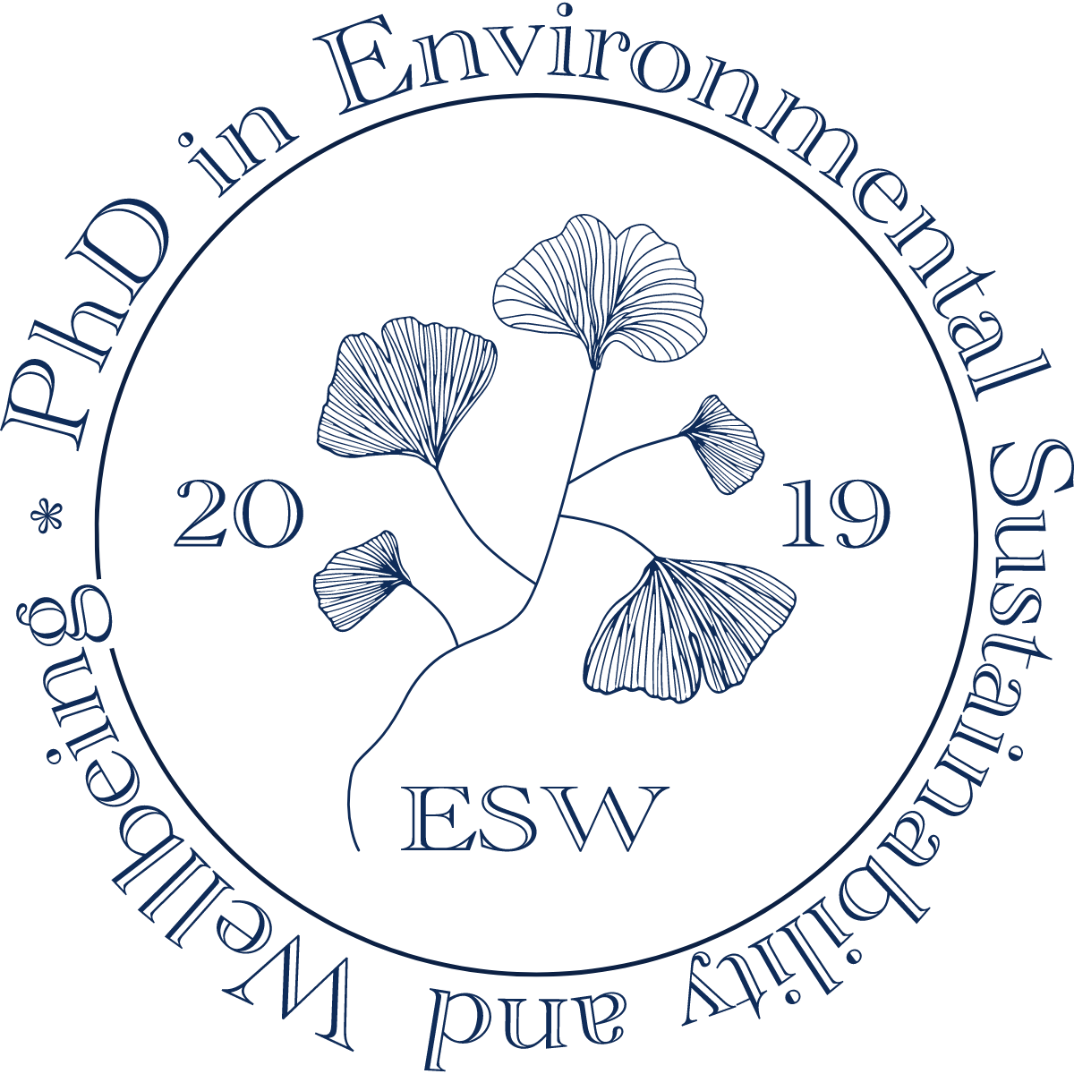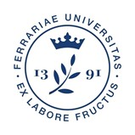
TEACHING ACTIVITIES 2021-2022
Face-to face + Streaming
AULA MAGNA IUSS – Corso Porta Mare 2 – Ferrara
35 SEATS
NOVEMBER | DURATION  TITLE OF SEMINAR  NAMES AND RESEARCH AREAS OF SPEAKERS | ABSTRACT
Monday
1
Tuesday
2
Wednesday
3
Thursday
4
Friday
5
Saturday
6
Sunday
7
Monday
8
Tuesday
9
Wednesday
10
Thursday
11
Friday
12
Saturday
13
Sunday
14
Monday
15
Tuesday
16
Wednesday
17
Thursday
18
Friday
19
Saturday
20
Sunday
21
Monday
22
Tuesday
23
Wednesday
24
Thursday 25 | 9:00-18:00  Third Annual Symposium of the PhD Programme in Environmental Sustainability and Wellbeing
Friday 26 | 9:00-18:00  Third Annual Symposium of the PhD Programme in Environmental Sustainability and Wellbeing
Saturday 27 | 9:00-13:00  Third Annual Symposium of the PhD Programme in Environmental Sustainability and Wellbeing
Sunday
28
Monday
29
Tuesday
30

DECEMBER | DURATION  TITLE OF SEMINAR  NAMES AND RESEARCH AREAS OF SPEAKERS | ABSTRACT
Wednesday 1 | 9:30-12:30  PASTORAL CRITICISM IN THE CONTEXT OF THE ENVIRONMENTAL HUMANITIES  Stefano Rozzoni, University of Bergamo  Chair  Elisa Bolchi, University of Ferrara | Half-day Seminar  Topics  Hubert Zapf’s discussion on cultural ecology and sustainable texts (2016) and the 5Rs of environmentalism – Reuse, Reduce, Recycle, Rot, and Repair – will be incorporated into a literary perspective on pastoral poetry.
Thursday
2
Friday
3
Saturday
4
Sunday
5
Monday
6
Tuesday
7
Wednesday
8
Thursday
9
Friday
10
Saturday
11
Sunday
12
Monday
13
Tuesday
14
Wednesday
15
Thursday 16 | 9:00-18:00  ANNUAL WORKSHOP OF THE CERCIS CENTRE ON CIRCULAR ECONOMY INNOVATION SMES  Reinhilde Veugelers  Keynote on environmental Policy, EU Green Deal and Innovations, https://www.bruegel.org/author/reinhilde-veugelers  ESW PhD students can set up a session within the event
Friday 17 | 9:00-18:00  ANNUAL WORKSHOP OF THE CERCIS CENTRE ON CIRCULAR ECONOMY INNOVATION SMES  Johan Eyckmans  Keynote on the Law & economics for the Circular Economy  https://www.kuleuven.be/wieiswie/en/person/00018075
Saturday 18 | 9:00-13:00  ANNUAL WORKSHOP OF THE CERCIS CENTRE ON CIRCULAR ECONOMY INNOVATION SMES
Sunday
19
Monday
20
Tuesday
21
Wednesday
22
Thursday
23
Friday
24
Saturday
25
Sunday
26
Monday
27
Tuesday
28
Wednesday
29
Thursday
30
Friday
31

JANUARY | DURATION  TITLE OF SEMINAR  NAMES AND RESEARCH AREAS OF SPEAKERS | ABSTRACT
Monday
3
Tuesday
4
Wednesday
5
Thursday
6
Friday
7
Saturday
8
Sunday
9
Monday
10
Tuesday
11
Wednesday
12
Thursday
13
Friday
14
Saturday
15
Sunday
16
Monday
17
Tuesday
18
Wednesday 19
Thursday
20
Friday
21
Saturday
22
Sunday
23
Monday
24
Tuesday
25
Wednesday 26 | 10:00-16.30  TOWARDS A SUSTAINABLE COMMUNICATION FOR (SCIENTIFIC) WELLBEING  Ivano Eberini, Università Statale Milan He is a computational biochemist with a wide experience in science communication through new media.  Federico Faloppa, University of Reading, UK  He is a sociolinguist and an expert in linguistic construction and representation of otherness; language and power; language policies. He is among the founders of the ‘Rete nazionale per il contrasto ai linguaggi d’odio’.  Chair  Elisa Bolchi, University of Ferrara | One-day seminar and workshop  Topics  In the morning Prof. Eberini will give a talk on the importance of ‘Science dissemination through new media’ and Prof. Faloppa will give a talk on the importance of using the right language when communicating ideas and the dangers of Hate Speech.  In the afternoon, Prof. Eberini will hold a practical workshop on how to prepare a dissemination plan.
Thursday
27
Friday
28
Saturday
29
Sunday
30
Monday
31

FEBRUARY | DURATION  TITLE OF SEMINAR  NAMES AND RESEARCH AREAS OF SPEAKERS | ABSTRACT
Tuesday
1
Wednesday
2
Thursday
3
Friday
4
Saturday
5
Sunday
6
Monday
7
Tuesday | COMMUNICATIVE STRATEGIES  AULA G  Dipartimento di Studi Umanistici, via Paradiso 12  meet.google.com/fbd-jrqj-hvx  10:15-11:15  Scripting the Communicative strategies of US mineral water in advertising. Are you buying water, cosmetics or drugs?  Walter Giordano, Università degli Studi di Napoli - Federico II  11:15- 12:00  Discussion  Chair  Eleonora Federici, University of Ferrara  Afternoon session:  14:00-17:00 Workshop  Communicative Strategies in Advertising  Emanuela Ammendola, Università Parthenope - Napoli  There are numerous communicative strategies that underlie advertising. Many of them have a linguistic nature, while others leverage on images or on other multimodal aspects (Kress and van Leeuwen 2006). Our investigation draws on the application of the prototype theory, and its ability to generate scripts that identify and contextualize single events, to advertising (St. Amant 2015, 2017). Specifically, the analysis focuses on print advertising of mineral water in the US.  The purpose is to demonstrate:  1) the strategic manipulation of communication through the swap of scripts, even though they belong to very different other categories;  2) the discursive change resulting from the script swap. The selected corpus consists of 80 US print advertisements from 2015 to 2021, selected from advertisements that appeared in magazines and on billboards, from different brands. Preliminary empirical results show that mineral water is contextualized in several scripts, ranging from pharmaceuticals, nutrition, cosmetics, and even oenology.  Chair  Eleonora Federici, University of Ferrara | One-day seminar
8
Wednesday
9
Thursday
10
Friday
11
Saturday
12
Sunday
13
Monday
14
Tuesday | 15:00-18:00  SPACE AND SOCIAL COEXISTENCE  Sara Lagi, University of Turin  Paola Spinozzi, University of Ferrara | Half-day Seminar  Topics  Creating spaces of sustainable, peaceful, and respectful coexistence among people emerges as a crucial and recurrent issue across civilizations.  By examining theories by different thinkers, we propose an interdisciplinary reflection on the relation between space and social coexistence.
15
Wednesday
16
Thursday
17
Friday
18
Saturday
19
Sunday
20
Monday
21
Tuesday
22
Wednesday
23
Thursday | ENGLISH TOURISM DISCOURSES AND INCLUSION  9.30-10.10  Stefania Maci, Università di Bergamo  Insights into the professional, promotional and digital languages of tourism and inclusion  10.10-10.30  Discussion  10.30-11.10  Mirella Agorni, Università Ca’ Foscari  Tourism, Translation and the challenges of accessibility and inclusion  11.10-11.30  Discussion  11.30-12.10  Tiziana Migliore, Università di Urbino  Migrants as tourists and tourists as migrants? A non-binary perspective  12.10-12.30  Discussion  12.10-12.50  Monia Castellini, Università di Ferrara  Valorisation of Cultural Heritage in Sustainable Tourism: management implications  12.50-13.10  Discussion  Chair  Eleonora Federici, University of Ferrara  Discussants: Sadat Al Sajib and Mohammad Mohiuddin | One-day seminar  ONLINE  meet.google.com/hri-afsb-efk
24
Friday
25
Saturday
26
Sunday
27
Monday
28

MARCH | DURATION  TITLE OF SEMINAR  NAMES AND RESEARCH AREAS OF SPEAKERS | ABSTRACT
Tuesday
1
Wednesday
2
Thursday 3 | EVOLUTIONARY BIOLOGY, ECONOMY, ECOLOGY – PART I  9:30-10:30  Evolutionary biology and population genetics: the basics  Giorgio Bertorelle, University of Ferrara  10:30-12:30  Economic evaluation tools: theoretical and practical aspects  Francesco Nicolli, University of Ferrara  14:30-15:30  Human activities and introduction of alien species: the impact on biodiversity  Cristina Munari, University of Ferrara | One-day seminar  Topics  Evolutionary biology and population genetics;  Principles of economic evaluation: contingent valuation, choice experiment, cost-benefit analysis, and multi-criteria analysis;  Effects of anthropogenic activities on biodiversity, in particular marine biodiversity and benthic communities
Friday
4
Saturday
5
Sunday
6
Monday
7
Tuesday
8
Wednesday
9
Thursday 10 | EVOLUTIONARY BIOLOGY, ECONOMY, ECOLOGY – PART II  9:30-10:30  Genetics as a tool to understand the biological impact of human activities and suggest conservation strategies  Giorgio Bertorelle, University of Ferrara  10:30-11:30  Economic evaluation tools: applications to different disciplines  Francesco Nicolli, University of Ferrara
Friday
11
Saturday
12
Sunday
13
Monday
14
Tuesday
15
Wednesday
16
Thursday 17
Friday
18
Saturday
19
Sunday
20
Monday
21
Tuesday | The PhD Programme in Environmental Sustainability and Wellbeing welcomes Paul Ekins  15:00-18:00  DECARBONISATION FOR NET ZERO | Seminar: 2-hour lecture + 1-hour Q&A  Paul Ekins  Professor of Resources and Environmental Policy  UCL Institute for Sustainable Resources  Email p.ekins@ucl.ac.uk  Web www.bartlett.ucl.ac.uk/sustainable  @UCL_ISR  Central House | 14 Upper Woburn Place  London | WC1H 0NN, UK
22
Wednesday | The PhD Programme in Environmental Sustainability and Wellbeing welcomes Paul Ekins  15:00-17:00  TUTORIALS | Discussion of 3rd- and 2nd-year students’ theses and 1st- year students’ research projects
23
Thursday | The PhD Programme in Environmental Sustainability and Wellbeing welcomes Paul Ekins  15:00-17:00  TUTORIALS | Discussion of 3rd- and 2nd-year students’ theses and 1st- year students’ research projects
24
Friday
25
Saturday
26
Sunday
27
Monday
28
Tuesday | The PhD Programme in Environmental Sustainability and Wellbeing welcomes Paul Ekins  15:00-18:00  CLIMATE CHANGE AND THE GLOBAL FOOD SYSTEM | Seminar: 2-hour lecture + 1-hour Q&A
29
Wednesday | The PhD Programme in Environmental Sustainability and Wellbeing welcomes Paul Ekins  15:00-17:00  TUTORIALS | Discussion of 3rd- and 2nd-year students’ theses and 1st- year students’ research projects
30
Thursday | The PhD Programme in Environmental Sustainability and Wellbeing welcomes Paul Ekins  15:00-17:00  TUTORIALS | Discussion of 3rd- and 2nd-year students’ theses and 1st- year students’ research projects
31

APRIL | DURATION  TITLE OF SEMINAR  NAMES AND RESEARCH AREAS OF SPEAKERS | ABSTRACT
Friday 1  MONARI TUTTO IL GIORNO | 9:00-13:00  WASTE TO ENERGY IN THE CIRCULAR ECONOMY: TECHNOLOGY, INSTITUTIONS, POLICIES  Roberto Zoboli, UNICATT  Claudia Ghisetti, UNIMI  Wilts Henning, WUPPERTAL  Chair  Massimiliano Mazzanti, University of Ferrara | Seminar
Saturday
2
Sunday
3
Monday
4
Tuesday | The PhD Programme in Environmental Sustainability and Wellbeing welcomes Paul Ekins  15:00-18:00  DEMATERIALISATION AND THE CIRCULAR ECONOMY | Seminar: 2-hour lecture + 1-hour Q&A
5
Wednesday | The PhD Programme in Environmental Sustainability and Wellbeing welcomes Paul Ekins  15:00-17:00  TUTORIALS | Discussion of 3rd- and 2nd-year students’ theses and 1st- year students’ research projects
6
Thursday | The PhD Programme in Environmental Sustainability and Wellbeing welcomes Paul Ekins  15:00-17:00  TUTORIALS | Discussion of 3rd- and 2nd-year students’ theses and 1st- year students’ research projects
7
Friday
8
Saturday
9
Sunday
10
Monday
11
Tuesday | The PhD Programme in Environmental Sustainability and Wellbeing welcomes Paul Ekins  15:00-18:00  SUSTAINABILITY AND SUSTAINABLE DEVELOPMENT | Seminar: 2-hour lecture + 1-hour Q&A
12
Wednesday 13 | 9:00-12:30  RE-ASSESSING HISTORICAL HERITAGE  Pietromaria Davoli, University of Ferrara  Paola Spinozzi, University of Ferrara  Marta Calzolari, University of Ferrara  Paola Boarin, University of Auckland  III. Architecture, Urban Planning, Engineering – Macroarea (III.1. Architecture and Urban Planning)  I. Humanities and Social Sciences – Macroarea (I.1. Humanities)  The PhD Programme in Environmental Sustainability and Wellbeing welcomes Paul Ekins  15:00-17:00  TUTORIALS | Half-day Seminar  Topics  Green Building Council Italia - Historic Building protocol  Research and preliminary analysis methods in the field of energy-environmental retrofit of existing heritage  Energy-environmental screening and assessments of 49 compounds at the University of Ferrara with a focus on a PhD research project  The Case of Ironbridge, UK  Discussion of 3rd- and 2nd-year students’ theses and 1st- year students’ research projects
Thursday | The PhD Programme in Environmental Sustainability and Wellbeing welcomes Paul Ekins  15:00-17:00  TUTORIALS | Discussion of 3rd- and 2nd-year students’ theses and 1st- year students’ research projects
14
Friday
15
Saturday
16
Sunday
17
Monday
18
Tuesday
19
Wednesday
20
Thursday
21
Friday
22
Saturday
23
Sunday
24
Monday
25
Tuesday
26
Wednesday
27
Thursday
28
Friday
29
Saturday
30

MAY | DURATION  TITLE OF SEMINAR  NAMES AND RESEARCH AREAS OF SPEAKERS | ABSTRACT
Sunday
1
Monday
2
Tuesday
3
Wednesday 4 | ENERGY TRANSITIONS TOWARDS GREEN ECONOMY MODELS AND INNOVATIVE DWELLING: ECONOMIC AND ENVIRONMENTAL ASPECTS  9:00-13:30  Pietromaria Davoli  Massimiliano Mazzanti  Marta Calzolari  Vittorino Belpoliti  Maria Velardi  Laura Gabrielli  Aurora Ruggeri  Pablo Del Rio Gonzalez  III. Architecture, Urban Planning, Engineering – Macroarea (III.1. Architecture and Urban Planning)  II. Economics and Law – Macroarea (II.1. Economics) | Half-day Seminar  Topics  Energy Transitions: from a Carbon-Based to a Green Economy. European and Global Scenarios  LCA and LCC: Tools, Techniques and Models  Do Auctions Promote Innovation in Renewable Energy Technologies?  Socio-economic Scenario of the Construction Development in the United Arab Emirates  The Solar Decathlon University Competition and the Case Study of KNOW-HOWse Team Project for SD Middle East, Dubai  Setting up an LCC Model for the KNOW-HOWse Team Project
Thursday
5
Friday
6
Saturday
7
Sunday
8
Monday
9
Tuesday
10
Wednesday 11 | POLITICAL ECOLOGY FROM AN INTERDISCIPLINARY PERSPECTIVE: THEORETICAL APPROACHES AND CASES STUDIES  h. 9:00-13:30  Alfredo Alietti, University of Ferrara, sociologist  Andreas Exner, University of Graz, political scientist  Giacomo D’Alisa, University of Coimbra, economist  Viviana Asara, University of Ferrara sociologist | Half-day Seminar  Topics  The interdisciplinary field of political ecology will be explored by delving into some of the manifold directions it has given rise to, thanks to its cross-fertilisation with disciplines from sociology to political science to human geography and ecological economics. After a first general introduction on the nature and birth of political ecology (A. Alietti), A. Exner will deal with the topic of extractivism from a political ecology perspective, deepening the issue of ecologically unequal exchange, land grabbing and the imperial mode of living. G. D’Alisa will introduce the topic of social metabolism, looking at the case of waste (case study of Campania) and circular economy from a political ecology and ecological economics perspectives. Finally, V. Asara will provide an account of socio-environmental conflicts and social movements as well as on the alternative practices that these engender at the urban level (case study of Barcelona).
Thursday
12
Friday
13
Saturday
14
Sunday
15
Monday
16
Tuesday
10
Wednesday
11
Thursday
12
Friday
13
Saturday
14
Sunday
15
Monday
16
Tuesday
17
Wednesday | BOOK PRESENTATION  17:00-18.30  Gianfranco Franz  L'UMANITÀ A UN BIVIO. Il dilemma della sostenibilità a trent'anni da Rio de Janeiro (Milano: Mimesis, 2022).  [HUMANITY AT A CROSSROADS. The Dilemma of Sustainability Thirty Years after Rio de Janeiro]  Discussants: to be defined  Research area: sustainability studies | 30 years after Rio de Janeiro, our ‘big world’ is at a crossroads: it must choose whether and how to orient itself towards individual and mass behaviors based on the moderation and parsimony of resource consumption or continue on those oriented to dissipation and infinite growth. We will not know which direction to choose if we are not supported by appropriate words.
18
Thursday
19
Friday
20
Saturday
21
Sunday
22
Monday
23
Tuesday | SOCIAL INNOVATIONS FOR SUSTAINABLE DEVELOPMENT  Giulio Ecchia, University of Bologna  Chair  Massimiliano Mazzanti, University of Ferrara | Seminar
24

MANCA ORARIO
(inserito in EasyRoom, IUSS Calendar, Formaz. Disciplinare)
Wednesday
25
Thursday
26
Friday 27 | HOW SUSTAINABLE WAS THE ANCIENT WORLD? POLLUTION AND THE OVEREXPLOITATION OF NATURAL RESOURCES IN ANTIQUITY  h. 9:00-18:00  Rachele Dubbini,  Saskia Stevens  Kostas Sbonias | One-day Seminar  Areas  Archaeology, Geology, Anthropology, Ecology and Society
Saturday
28
Sunday
29
Monday
30
Tuesday
31

JUNE | DURATION  TITLE OF SEMINAR  NAMES AND RESEARCH AREAS OF SPEAKERS | ABSTRACT
Wednesday
1
Thursday
2
Friday
3
Saturday
4
Sunday
5
Monday
6
Tuesday
7
Wednesday
8
Thursday
9
Friday
10
Saturday
11
Sunday
12
Monday
13
Tuesday
14
Wednesday
15
Thursday
16
Friday
17
Saturday
18
Sunday
19
Monday
20
Tuesday
21
Wednesday
22
Thursday
23
Friday
24
Saturday
25
Sunday
26
Monday
27
Tuesday
28
Wednesday
29
Thursday
30

